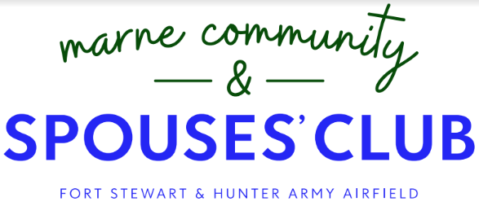
Grant Request Application

The Marne Community and Spouses’ Club (MCSC) is pleased to be able to provide financial assistance to deserving nonprofit organizations in accordance with the criteria stated herein and within the Marne Community and Spouses’ Club Bylaws.

Application Criteria:
- Must be located in one of the following counties: Bryan, Chatham, Effingham, Evans, Liberty, Long, McIntosh, or Tattnall.
- Must serve at least 25% of military members, dependents, or veterans.
- Grant must be specifically to benefit military members, dependents, or veterans.
- Must be actively fundraising.
- Cannot be for events, travel, salaries or other operating expenses, which establish a business’ existence.
- Must have a business account in which the check is made payable.
- If received a grant in the prior giving period, must have provided evidence that the grant was used for the intended purpose within 6 months of the grant’s issuance.

The open application period is December 1 ending March 1. All applications must be received within this period in order to qualify for the spring disbursement. Email the completed request to grants@marnecommunityandspousesclub.com. No mailed or late submissions will be accepted. Attach additional pages if necessary. All applications must be specific in nature and fully complete.

Today’s Date _________
ORGANIZATION INFORMATION

Organization's Full Legal Name*:
Type of Organization: 501(3) c) Other: ____________________________________
Street Address: City: State: Zip:
Point of Contact: Email: Phone:

*Check will be made payable to organization

Organization Mission Statement:

Brief Description of Organization:

GRANT INFORMATION

Grant Amount Requested:

Specific purpose of grant request. Include items to be purchased, costs of goods/services, etc. to justify the amount of grant request:

Who are the beneficiaries of this grant?

How many beneficiaries will receive assistance from the grant?

What percentage of the beneficiaries are military?

What other avenues of fundraising does your organization/group have/utilize?

Describe last fundraising event/date:

Have you received a grant from MCSC in the past two years? Yes _____ No ____

PUBLICITY RELEASE

I DO _____ I DO NOT ______ give MCSC permission to use my name and any image of myself for the purpose of publication in media outlets, including print, newspapers, radio, television, online and specifically the MCSC social media pages.
Signature: ______________________________

________________________________________________________________________________________
Internal Use Only Circle One: Approved Denied

Amount: Check Number: Date Grant Awarded:

Denial Reason (if applicable):

If approved, was evidence of grant’s use received within 6 months of its issuance? (Attach in file)
________________________________________________________________________________________

