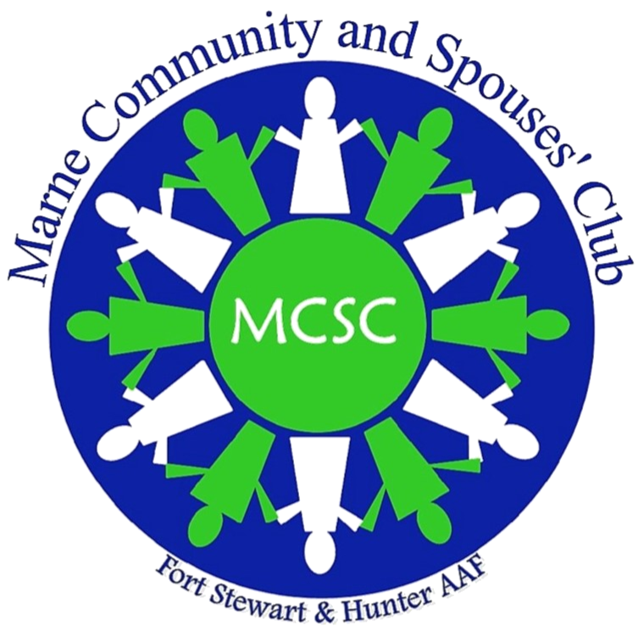
Marne Community and Spouses Club
Reservations Policy
2019 - 2020

The Marne Community and Spouses’ Club (MCSC) hosts periodic luncheons and events, and the reservations policy has been enacted in order to streamline the reservations process and to ensure that members understand the reservations deadline, the cancellation policy, and the club’s policy regarding walk-ins and guests. This policy was established to ensure that all MCSC members have an enjoyable event experience, to maximize club resources, and limit undue expenses that can arise from inaccurate headcounts and late cancellations.

Making a Reservation: All MCSC members will receive an email at least three weeks prior to the event. The email will direct you to the MCSC website where you will reserve your spot for the event, or you may make your reservation directly at http://www.marnecommunityandspousesclub.com/get-involved.

The event invitation will contain pertinent information such as date, time, and place, and will include the welfare project for the month. To guarantee your reservation, you must RSVP through the website link. Your response must be received no later than 12:00PM on the deadline indicated in the event invitation, one week prior to the event. Responses made after the deadline will be placed on a waiting list and ARE NOT guaranteed a reservation to the event. All RSVPs done online will require an electronic online secure payment. If you would like to prepay via cash or check, you may do so at a luncheon event and prepay for the next month’s luncheon.

Additionally, in the event that the website is unable to process RSVPs or otherwise becomes unavailable, please send your reservation to the Reservation Chairperson at reservations@marnecommunityandspousesclub.com. The same requirements for confirming a reservation via the website link also apply for emailing reservations.

Email Confirmation: All reservations and cancellations will be confirmed by an email from the Reservations Chairperson to the MCSC member. If you do not receive a confirmation email within 48 hours of making your reservation, please re-submit your response as it may not have gone through.

Cancellation of a Reservation: To cancel a reservation and receive a refund, send an email to reservations@marnecommunityandspousesclub.com by 12:00pm, one week prior to the event date. In order to receive a refund, you must cancel before the deadline. Cancellations for refund made after the deadline will not be honored. MCSC is obligated to pay for all reserved meals, regardless of attendance to the event.

Payment for Non-Attendance: If you receive an email for non-attendance, you will not be able to attend the next luncheon or event until the past due amount is paid. You will be invoiced for the outstanding balance and will pay for it within 24hrs of the next MCSC event. If you choose to mail the payment, please address it to:

MCSC Reservations
P.O. Box 3119
Fort Stewart, GA 31315

Walk-Ins: Walk-ins will be allowed if seats become available due to cancellations, but only after the waiting list has been depleted. Walk-ins are not guaranteed at any luncheon location.

Guests and Non-Members: MCSC members may bring guests to the programs. A guest or non-member who is eligible to become a MCSC member may only attend one MCSC luncheon as a guest. In order to attend additional luncheons, the guest must become a member.

Business Associate Members: Businesses that have applied for associate membership may send a maximum of two employees as their representatives to the monthly luncheons.

Please contact the Reservations Chairperson listed below if you do not have access to email or with any questions you may have regarding this policy.

Diana Reynolds
(719) 243-8621
reservations@marnecommunityandspousesclub.com

