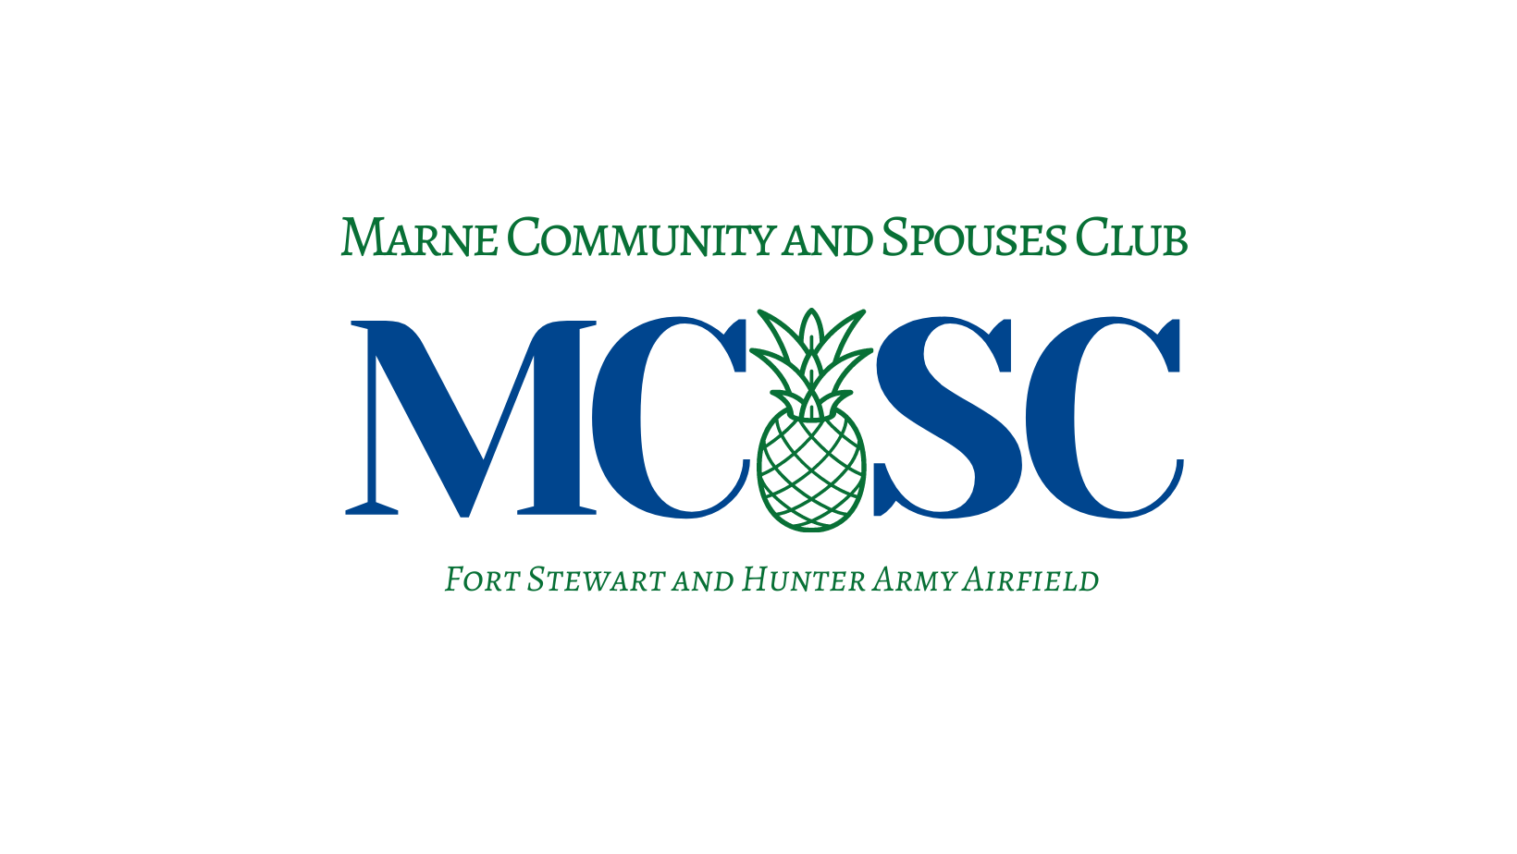
MCSC Scholarship Application Instructions 2021 – 2022

These instructions are for your reference. Please apply online at Scholarships and Grants | MCSC

The Marne Community and Spouses’ Club (MCSC) Scholarship Fund is one of the many ways
the club helps enrich the communities of Fort Stewart, Hunter Army Airfield, and the Low
Country. Our goal is to provide merit-based scholarships for eligible military family members of
the community. The MCSC will award scholarships based on the following criteria: academic
achievement, community involvement, extracurricular activities, essays, and letters of
recommendation. Applicants will be considered without regard to race, ethnicity, religion, rank
of sponsor, age, gender, sexual orientation or financial need.

ELIGIBILITY
1. The applicant must be attending an accredited institution of secondary education to include
vocational, associate, undergraduate or graduate degree.
2. High school applicants must be graduating in the 2022 school year.
3. College applicants must have graduated from an accredited high school or hold a GED
equivalent.
4. In order to be considered as a candidate, please complete the online application and submit all
required documents electronically time-stamped, no later than 11:59 p.m. EST February 15, 2022.
5. Applications without an attached résumé and essay will not be considered. Applicants' names
must appear in the file name of the résumé and essay. Electronic copies of your résumé and essay that
do not include your name in the file name will not be considered.
6. Applicants must be a Military Dependent I.D. card holder.
7. Recipients may retain the MCSC scholarship regardless of other scholarships received, UNLESS
the recipient receives a full four-year scholarship or an appointment at a military academy. These recipients will not be eligible for the MCSC scholarship. If the recipient does accept a full four-year scholarship or an appointment at a military academy, he/she must notify the scholarship chairperson via email.
8. Scholarships will be awarded in the following categories: a. High School Senior, b. Continuing
Education (i.e. vocational, associate, undergraduate, graduate), and Spouse.

PROCEDURE
1. The application submission must include:
a. High school students and first-time college students: An official high school/GED
transcript(s), the application with all applicable fields completed, typed essay, two (2) original
letters of recommendation, a student résumé and a copy of the college entrance exam scores.

b. Continuing and graduate education students: An official copy of college
transcript(s), the application with all applicable fields completed, typed essay, two (2)
original letters of recommendation, a student résumé, copy of official high school
transcript if freshman (first year) in college.
2. All properly submitted applications will be reviewed and evaluated by the Marne Community and
Spouses' Club in accordance with the guidelines. All information on the application will be
treated in a confidential manner.
3. Scholarship money will be sent directly to the recipient’s institution of higher learning.
Scholarship money must be used for tuition, room and board, internships, books, equipment
and/or meal plans.
4. Scholarships will be awarded in time for the Fall semester of the 2022-2023 academic year.
Once the scholarship has been awarded it will be up to the student and institution to apply the
scholarship for intended purposes. MCSC cannot and will not hold monies awarded for future
semester use.
5. All applicants will be notified by email of the outcome of the scholarship awards.

CHECKLIST
It is recommended that prior to completing the application, you review all the information
listed on this scholarship web page to determine if you are eligible. You will not be
considered for a scholarship if your application package is incomplete.

A complete application package will include online submissions of application, essay, résumé, and emailed supporting documents to include official transcripts, letters of recommendation and any applicable entrance exams.
All documents must be submitted no later than 11:59 p.m. EST, February 15, 2022. Late applications will not be accepted.

Must be submitted online with Google Account:

Application
❑ Can be edited after submission until 11:59 p.m. EST on February 15, 2022.
❑ Any edits after 11:59 p.m. EST on February 15, 2022 will void your application.
Essay response
❑ Must be titled with your name in file name.
❑ Must be a maximum of 500 words, single spaced in 12 pt. font with .5 margins.
Scholarship résumé
❑ Must be titled with your name in file name.
❑ Must include objective and academic experience such as grade point average,
AP/Honors and/or foreign language.
❑ Résumé should also include extracurricular activities, awards and honors.

Must be emailed and submitted no later than 11:59 p.m. EST on February 15, 2022:
Official transcript
❑ Must be from current school registrar or last school attended.
A copy of college entrance exams
❑ (if applicable)
Two (2) electronic, original letters of recommendation.
❑ Must be emailed from professional, teacher, or professor email account.

If you have questions about the MCSC Scholarship please contact the Scholarship Chair at scholarships@marnecommunityandspousesclub.com

MCSC Scholarship Application 2021-2022

Applicant’s Name: ______________________________________________________________
Applicant’s Home Address: ______________________________________________________
_____________________________________________________________________________
Applicant’s Home Phone Number: _________________________________________________
Applicant’s Email Address: _______________________________________________________
Alternate address and phone number (if applicable):____________________________________
_____________________________________________________________________________
Please indicate the scholarships category you are eligible under:
____ Military dependent and graduating High School Senior
____ Military dependent and Continuing Education student.
____ Military dependent, Initial/Continuing Education student and Spouse.

1. Name and address of the school you presently attend or last attended:
_____________________________________________________________________________
_____________________________________________________________________________
2. Date you graduated from high school or received your GED: __________________________
3. Grade point average through your MOST RECENTLY COMPLETED semester of high
school/college:
________________________________________________________________
4. College entrance examination scores (Please provide a copy of test scores if applicable):
SAT Verbal _____________ Math ___________ ACT Composite ________
COMPASS_______ Other _________
5. List colleges, universities, or vocational schools to which you have applied:
_____________________________________________________________________________
_____________________________________________________________________________
_____________________________________________________________________________
6. What course of study do you plan to follow: _______________________________________
____________________________________________________________________________

Please email all supporting documents requested below to:
scholarships@marnecommunityandspousesclub.com

❏ Official high school/GED transcript OR college transcript from school registrar.
❏ Two (2) electronic copies of letters of recommendation from teacher or professor’s school email account emailed to account above.
❏ Student Entrance Exams (if applicable)

Must be submitted no later than February 15, 2022

MCSC 2021-2022 Essay Question

In 500 words or less, please describe an event in your life where you took a leadership role and what you learned about yourself.

Attach essay response titled with your name to application submission. Must be a maximum of
500 words, single spaced in 12 pt. font with .5 margins.

I certify that all information and documents provided as part of this application is true and correct
to the best of my knowledge. I am aware that my submission may be forfeited for fraudulent
statements. I give my consent to the sponsoring organization considering this application to use
the information provided herein for the purpose of scholarship consideration. I also agree that, in
the event I am awarded this scholarship, Marne Community Spouse Club (MCSC) has permission
to use my name, picture, and scholarship award information in MCSC publications and
promotions.
Signature: ______________________________________________ Date: ______________

I DO ____ I DO NOT____ give MCSC permission to use my name and any image of myself for the purpose of publication in media outlets, including print, newspapers, radio, television, online and specifically the MCSC social media pages.

All information disclosed in this application will be treated confidentially and released only after
authorization by the applicant. This information is protected by the privacy act of 1974
(PL-93-579). Unauthorized access of this information is a violation of federal law. Violators will
be prosecuted.

2021-2022 MCSC Scholarship Application
For Committee Use Only Application # _______________ Date Rec’d _________________

